Atanas Kuzmanov 0830668

P.A.C.I.N.G.S. – PDA Android Campus Information Navigation Guidance System

Supervisor: Professor Huosheng Hu

Project Goals
The main purpose of this project is to develop the initial level of a framework of a system to help students and visitors have a better experience in the University of Essex, to help them navigate with ease. The system to be developed as an application based on an Android Operating System for an Android PDA (Personal Data Assistant) Smartphone. Since the product is to be developed for a structured environment it will have three main levels.
For the purpose of this project and in order to demonstrate the possible uses and benefits of such a system I intend to implement a couple of sample instruction-navigation examples in a mixed component, consisting of “Level 1: Outer View / GPS based component” and “Level 2: Inner View / Sign based component” called “Level 1: Mixed Outer View / GPS / QR based component”. (See “Figure 5. Use Case Diagram 2” in Appendix A, page 11)
System levels (See “Figure 1. Use Case Diagram 1” in Appendix A, page 10):
Level 1: Outer View / GPS based component
This level includes the outer view of the University of Essex, including objects around it such as the Sports Centre or the Lakes. This will help in navigating for example from the Courts Accommodation or from the Constable Building to the University buildings. In this level the main technology to be used is the PDA’s built in GPS (Global Positioning System) and Google Maps. The user can type the name of the desired location and it will be displayed on a digital map of the university. Further information and guidance how to get there will be available to the user thus enabling them to navigate form their current position to the desired destination. Additional data can be transferred by Wi-Fi / 3G / Cell networks.
Level 2: Inner View / Sign based component
At this level of functionality the software will help the user to navigate between University Buildings and Squares. The main technology used here will be QR codes. QR codes can be scattered across the University campus on important locations or hotspots, for example on Squares, Departments, at building entrances and places of entertainment. The user can scan a QR code with the PDA’s built in camera and thus obtain his current location which will appear on a digital map of the university. This way he will be able to see his position in relevance to other hotspots and get better orientation.
Level 3: Inside View / Sensor based component
At this level the application will help the user to navigate inside a University building. The main technology used here will be digital sensors assisted by the technology used in Level 2 – QR codes. More specifically the sensors will be the ones typical for an Android based HTC device: a G-Sensor/Accelerometer and a Digital Compass. Inside a building the user can scan a QR code to obtain his current position and then navigate to the next hotspot or destination kept correctly on the course with the help of the sensors which would count his steps (G-Sensor/Accelerometer) or keep track of his coordinates (Digital Compass) as the user goes along the way. See “Figure 1. Use Case Diagram 1”.
Level 1: Mixed Outer View / GPS / QR based component
This level is almost identical with “Level 1: Outer View / GPS based component” except that instead of the functionality being aided by Wi-Fi / 3G / Cell networks it is aided by QR codes.

Future project development:
- If time and resources suffice, to implement “Level 2: Inner View / Sign based component” and “Level 3: Inside View / Sensor based component”.
- If time and resources suffice, to implement a routing algorithm for navigating the user from current location to desired destination.
- If time and resources suffice, to implement Administrator Interface.
- If time and resources suffice, the system can be adapted to guide visually impaired people by streaming text, voice or other media information from a server. [5]
Methodology:
- For the development of the application I will use Eclipse Galileo Java EE Developers with the ADT plug-in and Android SDK as it is recommended in the Developer’s Guide in Android Developer’s website. [15] For testing I will use the mobile device emulator, part of the Android SDK.
- The reason for choosing the Android platform is that the Operating System already contains localisation API which can easily be extended. Most Android mainstream devices come with GPS (Global Positioning System)/Cell Location and Compass capabilities which can easily be extended via the LcoationProvider API to encompass alternative location sources such as Wi-Fi or Bluetooth. Also Android provides easy integration with Google Maps which can enhance the overall user experience.
- The PDA is to be from the HTC brand as they are generally fairly standard and compatible.
- On Android I would only have to use one language – Java, leading to an elegant solution, whereas in another device I would have to program in a mix of .NET CF and unmanaged C++ to access the GPS.

Required Development Software and Hardware:
- Windows 7 / Windows Vista with installed: MS Office 2007, MS Visio 2007, MS Project 2007, Firefox + Zotero, Eclipse Galileo Java EE Developers + Android SDK, IIS (Internet Information Server), Tomcat, MS SQL Server, MS SQL Management Studio, mySQL, Visual Studio 2010
- Laptop / PC Computer; Web Camera; HTC Legend PDA for advanced testing;

Background reading:
In order to come in better terms with the nature of this project first I had to understand what Navigation is. Navigation is the process of reading, and controlling the movement of a craft or vehicle from one place to another. [14] Navigation has always been man’s goal and necessity. In the past times of sailing, great geographical discoveries, conquering and explorations great ship captains used marine sextants, maps and read the stars in the night sky to determine their position and set correct course of the ship to safely reach their destination. In our time only the means of navigation have changed and it has become an important part of our daily lives. Now we use the latest in computer, radio, radar and satellite technology to assist everyone from a captain sailing a giant tanker using powerful computers to navigate, to a man using in car navigation to avoid traffic jams, to a girl using GPS on her latest range mobile phone to navigate to the nearest coffee house.
My research for the Level 1: Outer View / GPS based component led me to the following interesting finds:
“Open-android-navigator” [6]- It had little information as the project had low activity, but I saw the interesting features listed and I intend to use some of them for my project: Google Maps integration; Updating local database from remote server;
“Smart environments: Introduction to the special thematic session” [8], I interpreted this article as an idea that my product can be a component of a “Smart Environment”, for example a “smart home” or a “smart university”.
“Research and Implementation of Mobile Navigation System Based on GPS and GIS” [16] – this article had key aspects which I think are very relevant. The first and most important for me is “componentization design” which I interpret as developing a system in components, so that it is an elegant and effective solution to which new features can be added or removed from the framework. Another key point was “A-star shortest path algorithm” which I think can be used as additional technology in this component if necessary. I also researched what “GIS” stands and found out it was quite relevant to my area: “A geographic information system (GIS), geographical information system, or geospatial information system is any system that captures, stores, analyzes, manages, and presents data that are linked to location. In the simplest terms, GIS is the merging of cartography, statistical analysis, and database technology.” [17]
Continuing my research for Level 2: Inner View / Sign based component led me to the following results:
“A GPS navigation system with QR code decoding and friend positioning in smart phones”[2]. This was an open source GPS (Global Positioning System) navigation system for Android with many useful applications integrated. What caught my attention was “Quick Response (QR) code decoding” – feature also considered by me as mentioned before.
“tap-tours”[9]. Here is an excerpt clearly describing the main purpose: “TAP aims to provide tools to easily create and deliver mobile tour applications in a museum setting. Content creation is performed in the content management system, Drupal. TAP tours are exportable into an intermediate format, TourML, which can then be used as pluggable bundles for mobile applications.”[9] I think that this has very similar aspects to what I would like to achieve as it is for museum mobile tours. Instead of sensors it uses a 3 digit code to determine in front of which exhibit it is. In my case I intend to replace the 3 digit code in this example with QR Codes which can hold more information than just digits.
While doing the research part for Level 3: Inside View / Sensor based component I found:
“Open radio map based indoor navigation system”[3]. My point of interest was “Wi-Fi Fingerprints” as I believe in the same way Bluetooth or QR Code technology can be used fortified by G-Sensor/Accelerometer and/or Digital Compass.
“The design of a handheld, location-aware guide for indoor environments”[11] and I opened the paper in a web pdf reader. I was interested in the “Location Identification” section in which was suggested using: Wireless LAN Access Points, Bluetooth and Infrared technologies. In my opinion the these technologies are good alternative of the sensor-based approach I intend to take but I believe my approach is better as it would not require the installation of additional radio devices in the area of use.
Going further with my research for Future project development revealed:
“Initial development of a PDA mobility aid for visually impaired people”[5]. This was suggesting mobile navigation for visually impaired people. In the abstract it was said that the PDA prototype failed due to the use of GPS in built up environments. I think that this is a good idea and I think that my project might be further developed to help visually impaired students to get round campus easier.
I also went through materials used in my last year’s “CE202-5-FY: SOFTWARE ENGINEERING”[13] in order to refresh my skills gained during that module.
I researched last years’ “CC301-6-FY: Individual Project.”[1] page for deeper guidance and information and here I found out about digital libraries and accessing them through the University of Essex’s Library Website[3].
Bibliography:
[1] “CC301-6-FY: Individual Project.” [Online]. Available: http://courses.essex.ac.uk/cc/cc301/. [Accessed: 23-Sep-2010].
[2] “IEEE Xplore - Abstract Page.” [Online]. Available: http://0-ieeexplore.ieee.org.serlib0.essex.ac.uk/search/freesrchabstract.jsp?tp=&arnumber=5529943&queryText%3Dandroid+navigation%26openedRefinements%3D*%26searchField%3DSearch+All&abstractAccess=no&userType=inst. [Accessed: 26-Sep-2010].
[3] “IEEE Xplore - Abstract Page.” [Online]. Available: http://0-ieeexplore.ieee.org.serlib0.essex.ac.uk/search/freesrchabstract.jsp?tp=&arnumber=5470558&queryText%3Dandroid+navigation%26openedRefinements%3D*%26searchField%3DSearch+All&abstractAccess=no&userType=inst. [Accessed: 26-Sep-2010].
[5] D. McGookin, M. Gibbs, A. Nivala, and S. Brewster, “Initial development of a PDA mobility aid for visually impaired people,” in Proceedings of the 11th IFIP TC 13 international conference on Human-computer interaction - Volume Part II, pp. 665-668, 2007.
[6] “open-android-navigator - Project Hosting on Google Code.” [Online]. Available: http://code.google.com/p/open-android-navigator/. [Accessed: 23-Sep-2010].
[8] “SpringerLink - Abstract.” [Online]. Available: http://www.springerlink.com/content/e336035u5118361p/. [Accessed: 26-Sep-2010].
[9] “tap-tours - Project Hosting on Google Code.” [Online]. Available: http://code.google.com/p/tap-tours/. [Accessed: 26-Sep-2010].
[10] “The Albert Sloman Library: Databases for Computing and Electronic Systems.” [Online]. Available: http://libwww.essex.ac.uk/Electronic_Resources/Subject/dbcompelec.htm. [Accessed: 23-Sep-2010].
[11] C. Ciavarella and F. Paternò, “The design of a handheld, location-aware guide for indoor environments,” Personal Ubiquitous Comput., vol. 8, no. 2, pp. 82-91, 2004.
[13] “University of Essex :: Module Directory detail.” [Online]. Available: http://www.essex.ac.uk/courses/default.aspx?coursecode=CE202&level=5&period=FY. [Accessed: 02-Oct-2010].
[14] “Navigation - Wikipedia, the free encyclopedia.” [Online]. Available: http://en.wikipedia.org/wiki/Navigation#cite_note-bow799-0. [Accessed: 10-Oct-2010].
[15] | “The Developer's Guide | Android Developers.” [Online]. Available: http://developer.android.com/guide/index.html. [Accessed: 14-Oct-2010].
[16] He Li; Fan Jin-hong; Fu Xiao-ling; , "Research and Implementation of Mobile Navigation System Based on GPS and GIS," Information Science and Engineering (ICISE), 2009 1st International Conference on , vol., no., pp.2129-2132, 26-28 Dec. 2009
doi: 10.1109/ICISE.2009.895
URL: http://0-ieeexplore.ieee.org.serlib0.essex.ac.uk/stamp/stamp.jsp?tp=&arnumber=5455057&isnumber=5454428
[17] “Geographic information system - Wikipedia, the free encyclopedia.” [Online]. Available: http://en.wikipedia.org/wiki/Geographic_information_system. [Accessed: 14-Oct-2010].

Project Plan
Title | P.A.C.I.N.G.S. – PDA Android Campus Information Navigation Guidance System
Project Start | 06/10/2010 08:00:00
Project Finish | 16/05/2011 09:00:00

For the purpose of this project and in order to demonstrate the possible uses and benefits of such a system I intend to implement a couple of sample instruction-navigation examples in a mixed component, consisting of “Level 1: Outer View / GPS based component” and “Level 2: Inner View / Sign based component” called “Level 1: Mixed Outer View / GPS / QR based component”.
Since research and background reading for have already been done and now the project is at the Initial Report stage I will omit these tasks from the plan. I have also excluded stages such as “Interim Report”, “Project Poster” and supervisor meetings as I do not think they are relevant at this time and started from the “System Implementation” section of the Gantt chart. I have attached a snapshot of the full Gantt in Appendix A. (See “Figure 6. Gantt chart snapshot” in Appendix A, pages 12, 13)

Consequently the first stage is “Preparation for System Development”. It is an important initial stage as if the rest of the product development is to go smooth it is crucial for the development environment to work properly.
Next I will carry out “Skills Acquisition”. This is an important stage as together with my Java knowledge it will form the foundation of the skills required to build the project. I have allocated only a day for each sub-stage as the bigger part of the required knowledge I will obtain while working on implementation.
The next important building blocks are “Database Design”, at the end of which I will have an ER Diagram, and “Implementation of Database”, at the end of which I will have a simple database. The database will be at very initial stage but being well designed will allow it to elegantly grow and evolve, encompassing all the project needs. See “Figure 2. Gantt chart snippet 1” (I have not expanded “Skills Acquisition as it is has a lot of entries which are not so important at this moment).

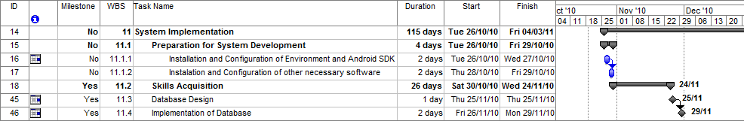
Figure 2. Gantt chart snippet 1
The next stage I intend to execute is development of the system framework by implementing core functionality of the three main levels. I intend to build the system to be modular, so that modules can be added or removed without affecting other ones. This is why each level or component of the system I have further broken down to subcomponents in order to achieve as little dependencies as possible. There will be of course compulsory fundamental building blocks from each level which will be represented as subcomponents.
“Level 1: Mixed Outer View / GPS / QR based component”. Following the Gantt chart the first subcomponent to implement is “Digital Maps” as it will be the canvas for the graphical representation of the navigation functionality. The next subcomponent in the schedule is “Google Maps” because I will map Google Maps coordinates to coordinates from the previous “Digital Maps” sub-module and store them in the Database. Next the “GPS” subcomponent is essential for “Google Maps” once it has been implemented and also for obtaining current position. For additional data and/or positioning the “QR Code” subcomponent will be implemented as it will process the information from a code input. The “Built-in Camera” subcomponent is the one responsible for reading the QR code and passing it as input to the above subcomponent. Since it should be more straightforward I have left it to succeed the more complex processing one. See “Figure 3. Gantt chart snippet 2”.
In the beginning I intended to proceed with “Integration of Modules / Components” an after that to apply the User Interface on top of the whole system. Later I decided it is more robust to look at the GUI (Graphical User Interface) as another component and integrate it together with the other core modules. See “Figure 3. Gantt chart snippet 2”.
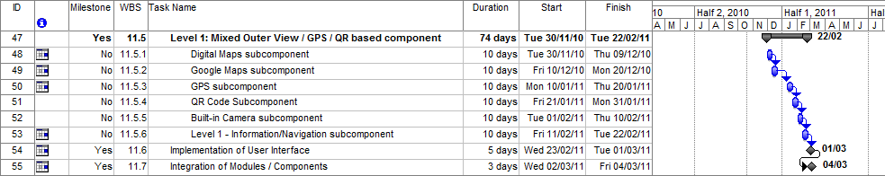
Figure 3. Gantt chart snippet 2

The next very important stage is “Testing and Debugging”. It consists of two sub-stages; the first one of which is “Module / Component Testing” is testing each component separately to make sure it works on its own. The next sub-stage is “Whole System Testing” which is testing the integrated build system to determine if it is performing correctly. See “Figure 4. Gantt chart snippet 3”.

After this stage from the Project Plan is completed I intend to concentrate upon working on the Final Report and preparing for the Project Demonstration and Oral Exam thus finishing with as much as possible completed stages. See “Figure 4. Gantt chart snippet 3”.
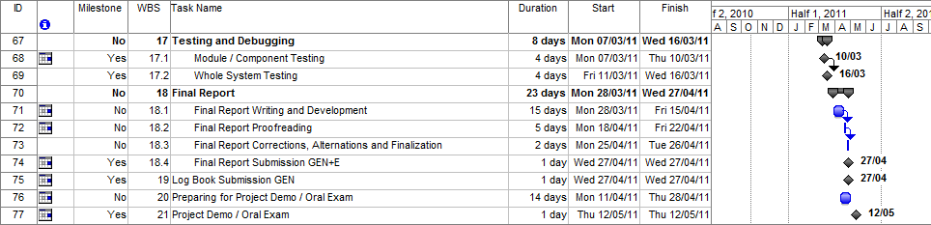
Figure 4. Gantt chart snippet 3

Appendix A
GPS subcomponent
C
Google Maps subcomponent
Digital Maps subcomponent
Wi-Fi / 3G / Cell Connectivity
subcomponent
QR Code subcomponent
C
Built-in Camera
subcomponent
QR Code subcomponent
C
G-Sensor /Accelerometer subcomponent
C
Digital Compass subcomponent
C
Digital Maps subcomponent
Digital Maps subcomponent
Built-in Camera
subcomponent
Level 1 – Information/Navigation
Level 2 – Information/Navigation
SYSTEM
Level 1: Outer View / GPS based component

Level 2: Inner View / Sign based component
Level 3: Inside View / Sensor based component

User
PDA
Google Maps
GPS
Wi-Fi Network
QR Codes
Figure 1. Use Case Diagram 1

GPS subcomponent
C
Google Maps subcomponent
Digital Maps subcomponent
Wi-Fi / 3G / Cell Connectivity
subcomponent
QR Code subcomponent
C
Built-in Camera
subcomponent
Level 1 – Information/Navigation
SYSTEM
Level 1: Outer View / GPS based component

User
PDA
Google Maps
GPS
Wi-Fi Network
QR Codes
Figure 5. Use Case Diagram 2

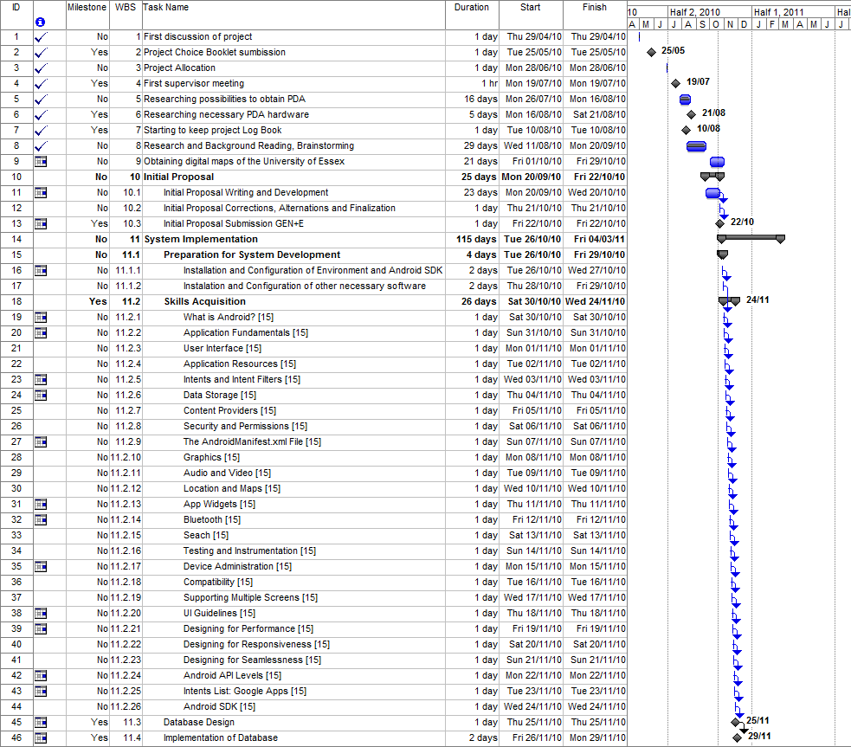
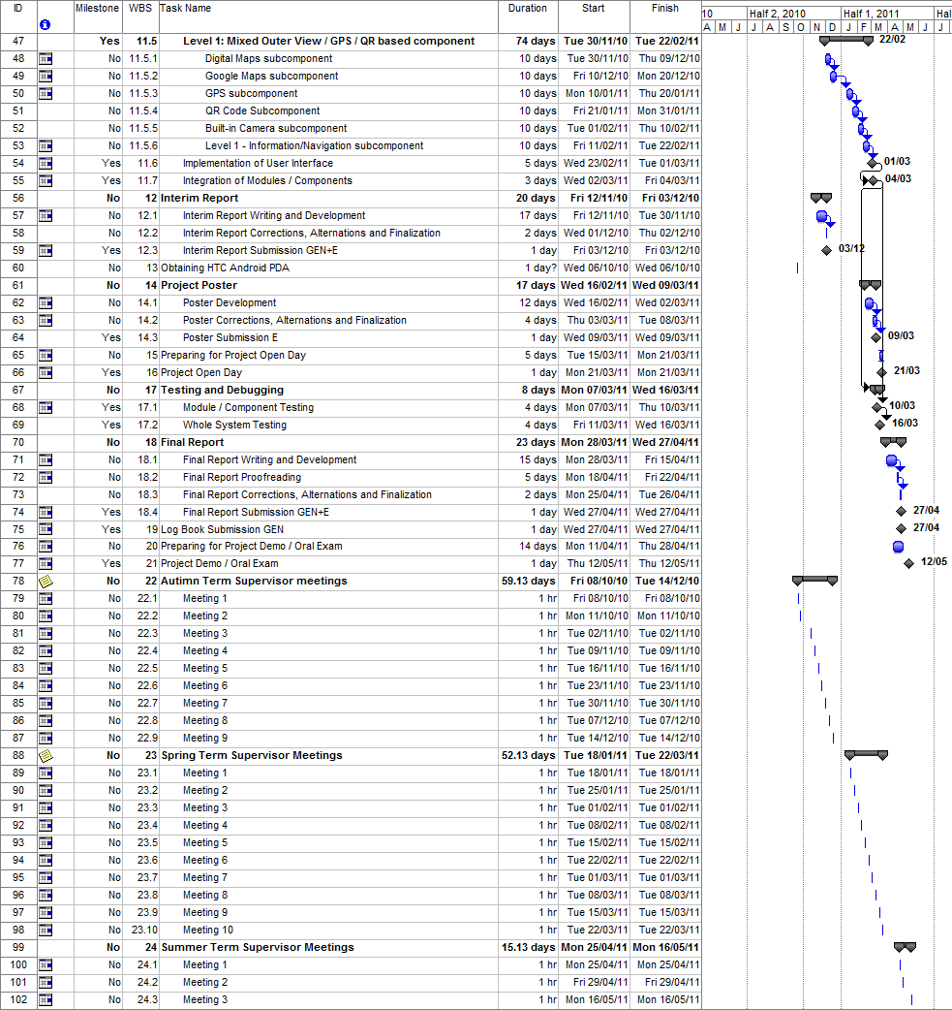
Figure 6. Gantt chart snapshot

